|  |  |
| --- | --- |
| http://att3.i.ua/attach/INBOX/5e4d45ce6c37/2/IMG_20200219_162559.jpg?I=cVaAj4F7aYRpnYVRvnBkhA%3D%3D | **S I N E K U R A**  **Ukraine, area. Dnipropetrovska, c. Dnipro, pr. Oleksandra Polia, build. 107Б, fl. 53**  **Email:** [**Isnekura@gmail.com**](mailto:Isnekura@gmail.com) **;** [Isnekura@i.ua](mailto:Isnekura@i.ua)  **Tel. What'sapp, viber +380 99 761 5759, tel +380952215466**  **sinekura.all.biz** |



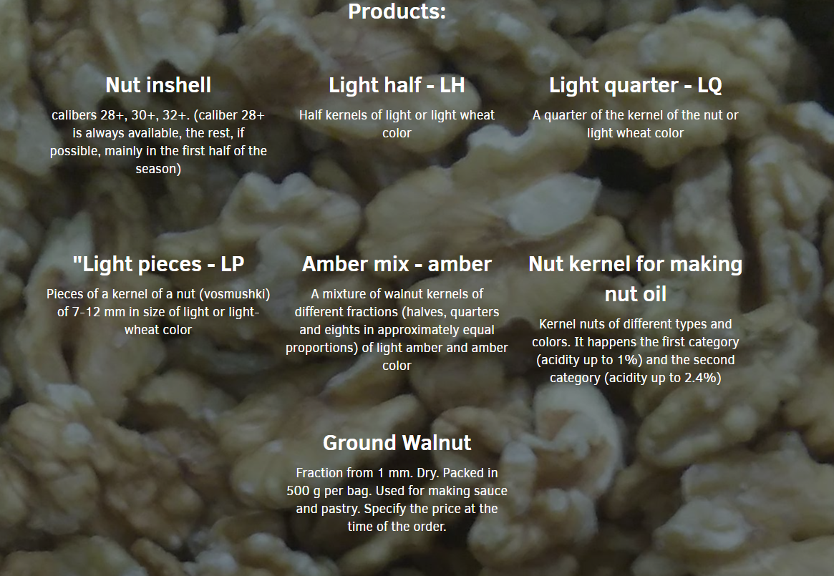



**Product gallery**

|  |  |
| --- | --- |
| https://www.sinekura.online/images/9.jpg | https://www.sinekura.online/images/12.jpg |
|  |  |
| https://www.sinekura.online/images/1.jpg | https://www.sinekura.online/images/18.jpg |
|  |  |
| https://www.sinekura.online/images/13.jpg | https://www.sinekura.online/images/2.jpg |
|  |  |
| https://www.sinekura.online/images/4.jpg | https://www.sinekura.online/images/11.jpg |
|  |  |
| https://www.sinekura.online/images/5.jpg | https://www.sinekura.online/images/7.jpg |
|  |  |
| https://www.sinekura.online/images/8.jpg | https://www.sinekura.online/images/16.jpg |

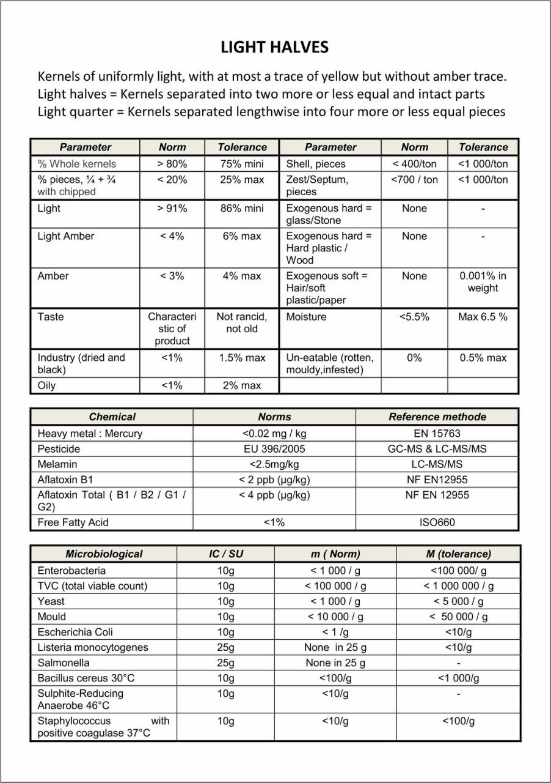

General Director

of the company Skuta Eduard Eduardovich